DRONELISTING.
STOCKPILE MEASUREMENT REPORT

Date: 15/04/2026- 13h00__
Site: _################__
Stockpile: __Secondary Floats_

1. Overview
A drone-based survey was conducted to measure the volume and surface characteristics of the stockpile. This report provides a quick and reliable estimate for operational use.

2. Methodology
• UAV aerial imagery captured
• Processed using WebODM
• Boundary defined and analysed
• Volume calculated using surface comparison

3. Measurement Output
Processing Software: WebODM

4. 3D Representation

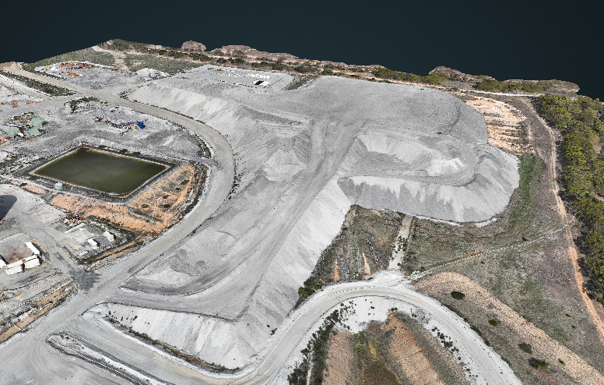
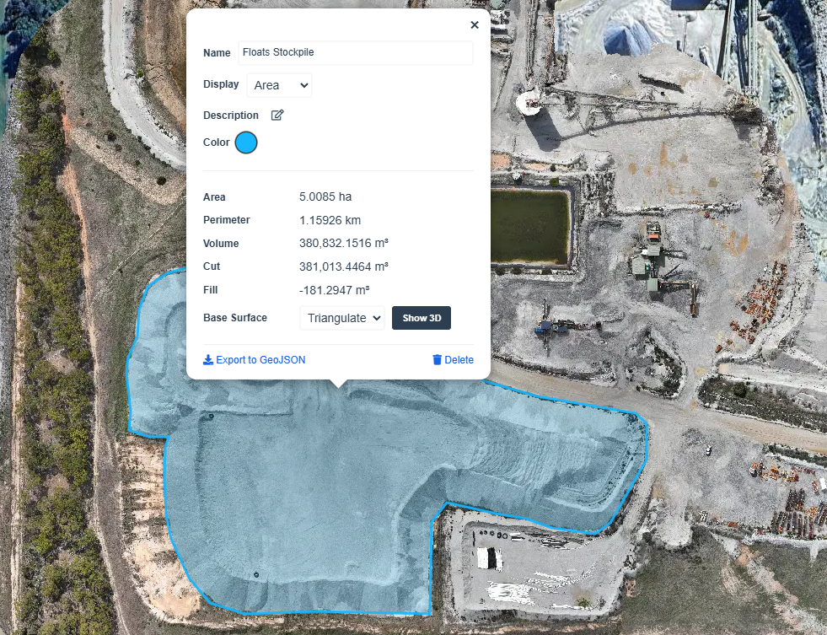

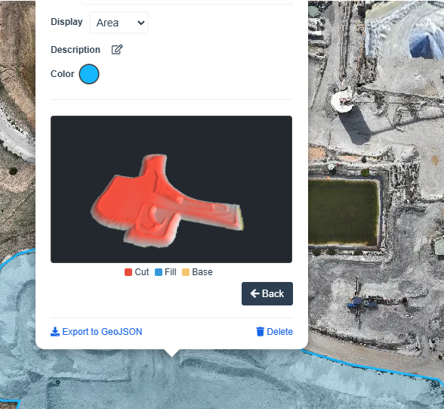

5. Notes
• Standard UAV operating conditions
• Base surface estimated
• Minor edge smoothing possible

6. Accuracy Statement
Estimated accuracy: ±3–5% (non-RTK)

7. Conclusion
The stockpile has been successfully measured and provides a reliable estimate for operational use.
Manny
ARN-1184858
Calculating Tons
